MEDIA RELEASE
FOR IMMEDIATE RELEASE 20 January 2023
The Cat Protection Society of Victoria calls for owners to step up
and microchip their cats

Despite being a legal requirement within Victoria, last year, 68 per cent of the stray and surrendered cats and kittens that came into The Cat Protection Society’s (CPSV) care weren’t microchipped. The CPSV is concerned that this may be reflective of the reality of the number of cats that aren’t microchipped across Victoria.
The CPSV’s Senior Veterinarian, Dr Peta Keown is urging more cat-owners to be responsible and have their cats microchipped.
“Microchipping is the most effective way to reunite lost cats with their owners. It is disappointing to see that in 2022 only 32 per cent of the cats that came into our care were microchipped.”
“There is no way for animal shelters like ours, the local vet, or the council to find a cat’s owner if they are not microchipped. It’s a very simple procedure that any vet can do which sees a tiny chip implanted under your cat’s skin,” Dr Keown said.
“The procedure is not invasive and doesn’t harm or hurt your cat. At our Vet Clinic, it costs $50 to have your cat microchipped or $125 with a Veterinary Consult and takes 15minutes. There is no recovery time needed. Kittens can be microchipped as young as 6 weeks old,” she said.
“It is also important that your contact details are kept up to date. If there are any changes, you must update your contact information on the Microchip database. To view the microchip database for your cat, visit www.petaddress.com.au,” she said.
Sarah Gibbons from North Melbourne knows all too well the importance of microchipping and is so grateful it enabled her to find her beloved cat Sleeves after two and a half years missing. The CPSV reunited her with Sleeves in 2019 after he went missing in the Swan Hill region in 2017.
“Sleeves was always the most personable and affectionate of our cats. When he was two, we were at our holiday home in Swan Hill, and devastatingly, he went missing. Although, I was heartbroken; we didn’t lose hope that he may return,” Sarah said.
“Over two and a half years past, and we didn’t see or hear any word about Sleeves. Fast forward to July 2019, and one day out of the blue my husband received a call from the CPSV asking if our cat was missing. I was beside myself. At first, we thought the CPSV must have been based in the Swan Hill region, but when we realized it was in Greensborough, we couldn’t believe it and how Sleeves had made it all the way to Melbourne,” she said.
“I was surprised that Sleeves was in such good condition. He was a little thinner than he is now but not too skinny and he had no bites, he was also in good spirits. As soon as we brought him home, he integrated back in seamlessly.”
“My understanding is that Sleeves would have travelled around 30 kilometres to the township of Swan Hill from our property. It astounds me to this day that he survived.”
“It was Sleeves’ microchip which enabled the CPSV to track him back to us,” she said.
You can view Sleeves in the 2023 Famous Felines Calendar. To find out more about microchipping or to book an appointment with the CPSV’s Vet please call (03) 8457 6504. You can download the CPSV’s New Year Pet Checklist here which includes other tips and ways in which vet owners can be responsible cat owners in 2023.

For further information please contact Katie Maynes PR: 0400 631 332 or email katie@katiemaynes.com

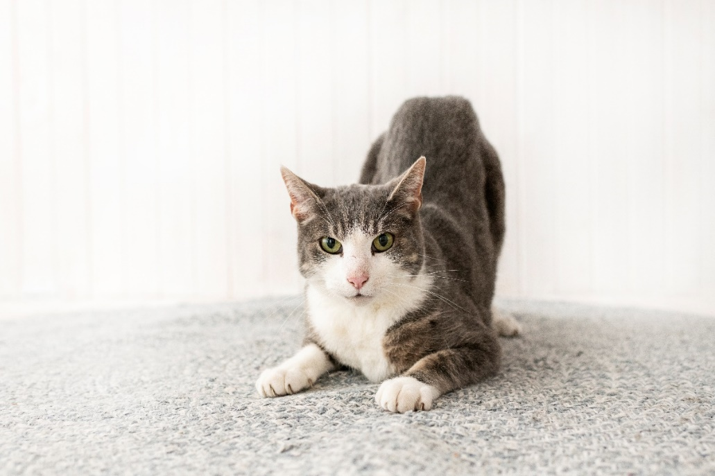
Sleeves pictured in the CPSV 2023 Famous Felines Calendar

